ASSIGNMENT : 5

Q1.Pick any one app you use daily (like Zomato, BookMyShow, or Spotify) and write a short description of a new feature you would want to build for it that would require cloud hosting and scaling.
Ans:
App: Zomato
Feature: Live Group Food Ordering
I would like to build a feature where a group of friends can create one shared food order. Each person can add their own items to the same cart, and everyone can see the order status in real time.
This feature would require cloud hosting and scaling because many users may use group ordering at the same time, especially during lunch, dinner, or weekends. Auto-scaling can add more servers when the number of users increases and reduce them when the traffic becomes low.
Why cloud scaling is needed:
It helps the feature handle high traffic smoothly without making the application slow or unavailable.

Q2.Draw a basic cloud architecture diagram (hand-drawn or using a tool like draw.io) for your chosen feature, including at least: a load balancer, two app servers, a database, and a storage service (like AWS S3 or Azure Blob). Label each component clearly.
Ans:
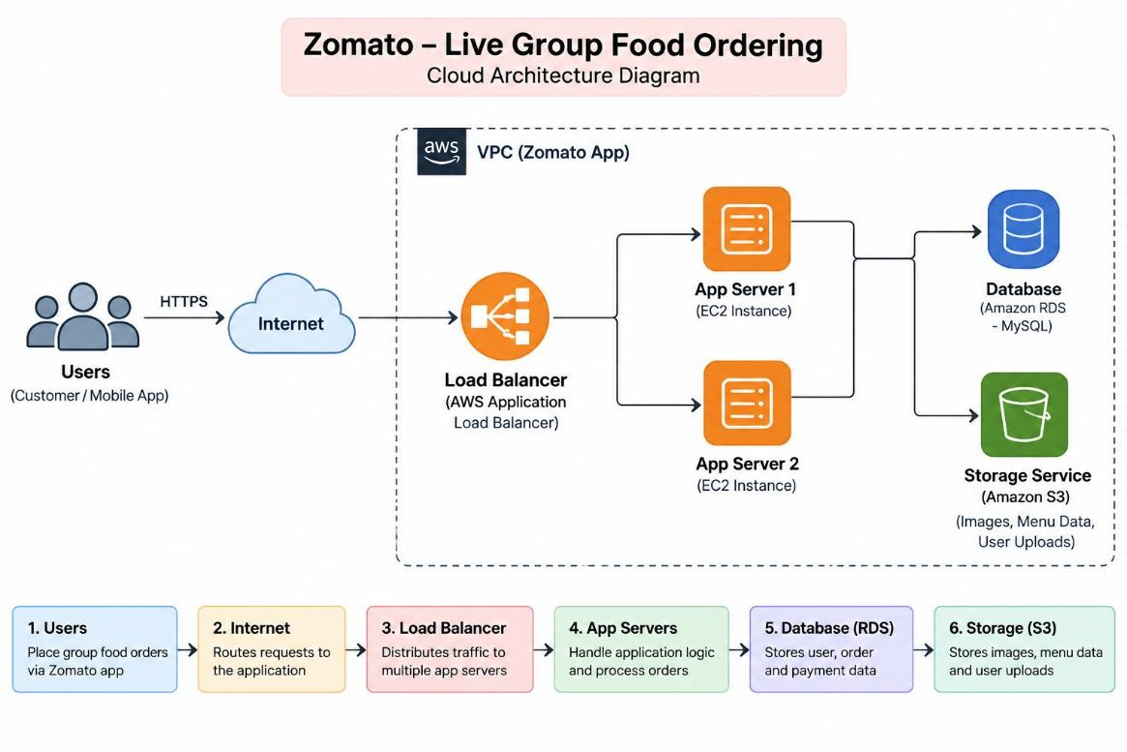
Q3.List three security measures you would add to your architecture to protect user data and authentication prevent attacks. For each, explain in 1-2 lines how it helps (e.g., HTTPS, firewalls, methods).
Ans:
Three Security Measures for the Architecture:
- HTTPS / SSL:
Encrypts data between users and the application, protecting login details, payment information, and other sensitive data from attackers.
- Firewalls / Security Groups:
Allow only required network traffic to the application servers and block unauthorized connections.
- Authentication and Authorization:
Ensures that only verified users can access their accounts and that users can access only the data and features they are allowed to use.

Q4.Write a short document (200-300 words) explaining how your architecture would handle a sudden spike in users during a big event (like IPL finals for BookMyShow or a major album release on Spotify). Describe which parts would scale and how.
Ans:
Handling a Sudden Spike in Users:
Suppose a large number of users suddenly start using the Live Group Food Ordering feature on Zomato during a big event, such as an IPL final. The cloud architecture would use auto-scaling to handle the sudden increase in traffic.
First, the Load Balancer would receive requests from users and distribute them across the available application servers. This prevents one server from receiving all the traffic and becoming overloaded.
The App Servers (EC2 instances) would be the main components that scale. When the number of users and CPU usage increases, the Auto Scaling Group would automatically launch additional EC2 instances. For example, if there are initially two app servers, it could increase them to four or five based on the traffic. The load balancer would then distribute new requests across these servers.
The Database (Amazon RDS) would store important information such as user accounts, group orders, and order details. It would be configured to handle increased database requests and maintain reliable access to data.
The Storage Service (Amazon S3) would store images, menu data, and user uploads. Since S3 is designed to handle large amounts of data and requests, it can support increased traffic without manually adding servers.
When the event ends and the number of users decreases, the Auto Scaling Group would automatically remove the extra app servers. This reduces unnecessary resource usage and saves cloud cost.
Overall, this architecture provides better performance, availability, and scalability during sudden traffic spikes.

Q5.Present your architecture design to a friend or family member, ask them for one piece of feedback or a question, and write down what they said along with your response. Hint: Focus on explaining your choices simply, as if you were talking to someone new to cloud computing.
Ans:
Feedback from Friend/Family Member:
I explained my Zomato Live Group Food Ordering cloud architecture to my friend. I explained the role of the load balancer, two app servers, database, and storage service.
Feedback/Question:
My friend asked, “Why do you need two app servers instead of only one?”
My Response:
I explained that two app servers can share the user traffic. If one server becomes busy or has a problem, the other server can continue handling requests. This makes the application more reliable and available.

